Source: http://www.guru99.com/an-expert-view-on-test-estimation.html

Three popular techniques for test estimation:

1. Work breakdown structure (WBS): By dividing the project into smaller pieces
2. Three points estimation: Bases on statistics data.
3. Function point method:

**Work Breakdown Structure:**

**Step 1:** Division of project into smaller tasks

* Analysis of project requirements
* Create the test specification

1. Design test scenarios
2. Design test cases
3. Review the test cases

* Execute the test cases

1. Prepare test environment
2. Execute test cases
3. Analysis the results

* Report defects

1. Create the defect report
2. Report the defects

**Step 2:** Estimate the efforts for tasks.

Two methods:

**First method:** Function point

**Second method:** Three point method

**Function point method:**

The following three things are computed in this method:

1. Size :
2. Duration
3. Cost

**First need to calculate the size then on the basis of that size, effort and cost is computed.**

How to calculate size: In this a size of particular task is calculated e.g. **“Create test specification”**

**Here “Create Test specification” can also be known as “Functional Point” as well.**

Now categorize this functional point into following categories: It depends upon the **FUNCTIONAL SIZE of** the task. The more the functional points contains functionality, the more it is complex.

* **Complex,**
* **Medium**
* **Low**

**Now assign the weight**

|  |  |
| --- | --- |
| **Group** | **Weightage** |
| Complex | 5 |
| Medium | 3 |
| Simple | 1 |
|  |  |

**Now calculate the efforts or duration:**

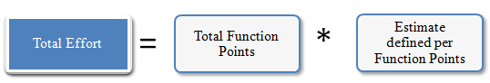

|  |  |  |  |
| --- | --- | --- | --- |
|  | **Weightage** | **# of Function Points** | **Total** |
| Complex | 5 | 3 | 15 |
| Medium | 3 | 5 | 15 |
| Simple | 1 | 4 | 4 |
| **Function Total Points** | | | **34** |
| **Estimate define per point** | | | **5** |
| **Total Estimated Effort (Person Hours)** | | | **170** |

**Second Method: Three Point Estimation:**

1. **The Best case estimate:**
2. **The most likely estimate:**
3. **The worst case estimate:**

http://cdn.guru99.com/images/TestManagement/testmanagement_article_2_2_11.png

**Here a=1st case, b=2nd case, c=3rd case**

**In this method, double triangular method is used:**

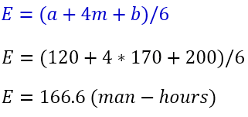

**Now calculate the Standard deviation to reach at near possible correct estimation:**

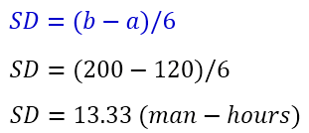

To complete the task “Create the test specification” of Guru99 Bank website, you need **166.6 ± 13.33** Man-hour (153.33 to 179.99 man-hour)